INITIAL ASSIGNMENT – GEOLOGY

Tectonic Plate Movements and Hotspots

Introduction

We are in motion no matter where we stand on the planet. The tectonic plates that compose the crust of the Earth are in motion at a measurable rate. Everything on the crust of the Earth changes its location in relation to the core of the planet. Yes, the plates are moving over the mantle, and we can measure this motion to determine the rate of plate movement by measuring the distances and times involved. Speed = distance/time
For example, if we know the past location of a certain island, then we can measure the distance between the present location of the island and its location millions of years ago, to determine the speed of the plate on which the island is located. This video explains it: https://www.youtube.com/watch?v=QO2OO1r_tFg

Fig. 1: Sample map showing present and past locations of an island
present location of island
North
latitude
distance between past and present locations (1,200 km)
location of island 40 Ma*
200 km
*Ma: million years before present
longitude

The example island in Figure 1 shows how this is done. If the island has moved 1,200 kilometers toward the northwest in 40 million years, then we can measure its average speed by dividing the distance moved by the number of years. Speed = distance/time.

1,200 kilometers =
40,000,000 years
0.00003 kilometers =
1 year
3 centimeters year
Thus, the rate of movement (speed) is 3 centimeters (cm) per year.

Hotspots

A convenient way to measure the distance moved by a land mass such as an island is by understanding hotspots. Hotspots are magma-rich locations within the upper mantle that cause volcanic activity in the crust of the earth directly above the hotspots. Hawaii and the Galapagos Islands are prominent examples of hotspot-related land masses.

It is assumed by geologists that hotspots generally stay in the same location within the mantle, and, as the crust of the earth passes over the mantle, new islands, for example, are produced as the older islands move away from the hotspot. Because the location of a hotspot is known, we know at what rate the island is moving away from the hotspot by learning the age of the rocks composing the island, along with measuring the distance of the island from the hotspot.
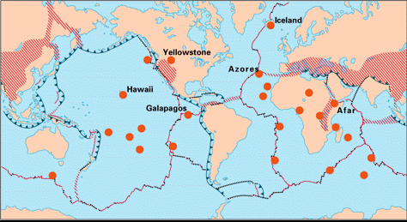

Figure 2. Map showing locations of geologic hotspots. Notice how many of them are located away from plate boundaries.

Galapagos Islands

The Galapagos Islands are a classic example of land created by a hotspot. The islands are quite curious scientifically with their relatively recent arrival in terms of geologic time and the unique characteristics of their flora and fauna. Charles Darwin was inspired by his visit there in 1834.

Hawaiian Islands

Rarely does something present itself as clearly as it does with the Hawaiian Island chain and plate tectonic theory. The chain of islands was formed by the Pacific Plate moving over a stationary hotspot within the mantle. As the plate moved over the hotspot, volcanic activity formed new islands. As a matter of fact, a future island named Loihi Seamount is forming to the southeast of the big island of Hawaii. It only lacks 1 kilometer before breaking the sea surface. If one travels to the northwest of the Hawaiian Islands, a chain of smaller islands that includes Midway Island can be found in line with the Hawaiian Islands. Further to the northwest, underwater mapping reveals seamounts also in a linear pattern with the islands. Curiously, there is a bend in the direction of the line of seamounts as one proceeds to the northwest of the Pacific Ocean. The Pacific Plate apparently changed its direction of movement within an instant of geologic time.

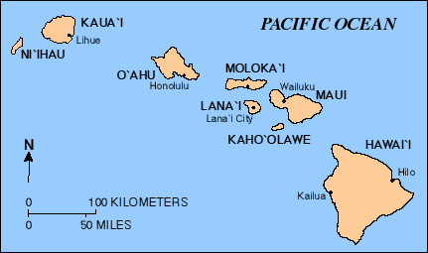

Figure 3. Map of the Hawaiian Islands. Notice how the islands tend to get smaller going toward the northwest. The ages of the islands get progressively older toward the northwest as the plate has traveled in that direction from the hotspot. The hotspot that created the islands is located underneath the big island of Hawaii.

Clearly, as one can see in Figure 2, most of the world’s hotspots occur beneath oceanic crust; however, they also are found below continental crust. The Yellowstone hotspot is a classic example. Yellowstone National Park would not exist if it were not for the hotspot underneath it. The past violent volcanic activity and the current milder volcanic activity in the region provided by the hotspot have produced a gloriously beautiful and interesting landscape. The geysers logically derive their heat from the magma chamber that lies shallowly (<1 km) beneath the park. It is certain that violent volcanic activity will occur again at Yellowstone. We don’t know when that will occur, but we know it will. With time, the land composing Yellowstone National Park will move away from the hotspot, so the park region will eventually cease to display volcanic activity, and new areas will show the effects of the hotspot. Perhaps the park will need to move to stay over the hotspot.
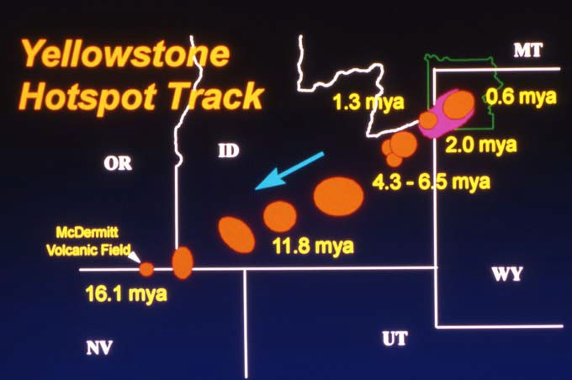

Figure 4. Map showing past and present locations of Yellowstone Hotspot as North American Plate traveled over hotspot. The orange circles represent calderas associated with volcanic activity resulting from the hotspot.

Activities | Activity Sheet  Hotspots

Name:

  - Read the transcript or listen to the audio at the PBS web site that is titled The Geology of the Galapagos Islands http://www.pbs.org/odyssey/voice/20000503_vos_transcript.html

Gather the following information from the site:

    - What is the name of the tectonic plate on which the Galapagos Islands are located?

    - In what general direction is the plate moving: north, south, east, or west?

    - How fast is the plate moving in centimeters per year (cm/yr)?

    - How far are the Galapagos Islands from the nearest continent in kilometers?

    - Based on the speed of the tectonic plate, how many years will it take for the Galapagos Islands to reach the edge of the nearest mainland (i.e. continent)?

  - The following questions show how the ages and distances between the Hawaiian
Islands reveal the speed of the Pacific Plate. The ages of the islands were acquired from a web site produced by the University of Hawaii: http://www.soest.hawaii.edu/GG/HCV/haw_formation.html .

    - Using the scale in Figure 3, measure the distance in kilometers from the center of the big island of Hawaii to the center of the island of Kauai to the northwest. The age of the island of Kauai is 5.1 million years. The hotspot is underneath the big island of Hawaii; therefore, use the distance you measured and the age of the island of Kauai to determine the rate of movement of the Pacific Plate over the Hawaiian hotspot.

Rate of movement of Pacific Plate (i.e. speed) =

    - The island of Lanai in the Hawaiian Island chain is 1.28 million years. Measure the distance from the center of the big island of Hawaii to Lanai to determine the rate of movement of the Pacific Plate between the Hawaiian hotspot and Lanai.

Rate of movement of Pacific Plate (i.e. speed) =

    - Based on the rates of movement that you calculated above, has the Pacific Plate rate of movement (i.e. speed) increased, decreased, or stayed the same from the past to the more recent? Explain how you determined your answer.

    - You are in charge of locating a geothermal plant on one of the Hawaiian Islands. On which island is it logical to find an excellent source of geothermal energy?

  - Look at Figure 4 and study the movement of the Yellowstone Hotspot. The orange circles on the map represent calderas, which are evidence of past volcanic activity associated with the hotspot that is now located underneath Yellowstone National Park. In the past, the hotspot was underneath what is now Oregon as indicated by the 16.1 million-year old McDermitt Volcanic Field.

    - Look at the trend of the ages of the calderas and notice how the calderas proceed from youngest to oldest in proportion to distance from the hotspot. The Yellowstone Hotspot is located beneath the North American Plate. Based on the directional trend of the calderas, in what direction is the North American Plate moving from the hotspot?

    - The Yellowstone Hotspot is underneath northwestern Wyoming at this time. In a few million years, under what state do you predict the hotspot will be underneath?

    - The distance between the Yellowstone and McDermitt Volcanic Field is approximately 725 kilometers (450 miles). Look at the Figure 4 map and notice the age of the caldera associated with McDermitt Volcanic Field. Based on that age and the distance from the hotspot, what has been the rate of movement (i.e. speed) of the North American Plate?

    - On the map, there is a caldera that is labeled as 11.8 mya (million years ago). The distance between this caldera and the hotspot underneath Yellowstone National Park is approximately 475 kilometers (295 miles). Based on the age and distance information, how fast has the North American Plate moved from the hotspot?

    - Compare the speed of the plate you calculated for Question 3.d. with the calculation you did in Question 3.c.. After comparing the two rates, has the speed of the North American Plate increased, decreased, or stayed the same over geologic time? Explain the reason behind your conclusion.

    - Regarding the speeds of the three tectonic plates studied in this lesson, put the names of the three tectonic plates in order from slowest to fastest:

slowest fastest

