

**dd**

**Positive Mental Health and Wellbeing Strategy**

Contents

1 AIM(s) 3

2 OBJECTIVES 3

3 Lead Members of Staff 4

4 Cedar Recording 4

5 Awareness of Mental Ill Health & Signposting 5

6 Indicators of Distress 6

7 Managing Disclosures 6

8 Confidentiality 7

9 Sharing Information/Informing Parents and Carers 8

10 Working with Parents/Carers 8

11 Supporting Peers 8

12 Staff Wellbeing 9

13 Support for Early Careers Teachers 10

14 Building Resilience 11

15 Promoting Positive Male Mental Health 12

16 Training 12

17 Signposting/Support 13

**17.1** **Appendix I** 14

**17.2** **Appendix 2** 16

**17.3** **Appendix 3** 17

**17.4** **Appendix 4** 20

In any instance where you have a concern about the safety of a student please follow the College’s safeguarding and child protection procedures.

The purpose of this document is to support students and staff, but it in no way supersedes the duty of staff to safeguard students in the College.

# **AIM(s)**

Ashton Sixth Form College (ASFC) aims to promote positive mental health for every member of our staff and student community. We pursue this aim using both whole-college approaches, and specialised, targeted approaches aimed at vulnerable students and to fully support staff in their time at the College.

As well as promoting positive mental health, we aim to recognise and respond to mental ill health. In an average classroom it is considered that three students will be suffering from a diagnosable mental health issue (TES 2020). By developing and implementing a practical, relevant and effective mental health strategy, we can promote a safe and stable environment in order for students and staff to “feel good and function well”.

In addition, in a community of 100 adults, approximately 20-25 will experience a mental health problem in any given year (Mind 2022). ASFC is a staff community approaching 220, so the potential figures are considerable.

The strategy aims to:

* Promote positive mental health for all staff and students
* Increase understanding and awareness of common mental health issues
* Alert staff to early warning signs of mental ill health being displayed by students or colleagues
* Provide support to staff working with young people with mental health issues
* Provide support to students suffering mental ill health, and their peers and parents/carers as well as colleagues/staff.

# **OBJECTIVES**

*Mental health is a state of mental well-being that enables people to cope with the stresses of life, realise their abilities, learn well and work well, and contribute to their community.*

*(World Health Organisation)*

This document describes our approach to promoting positive mental health and wellbeing. This strategy is intended as guidance for all staff, including non-teaching staff and Governors.

This strategy should be read in conjunction with the Stamford Park Trust (SPT) Keeping Children Safe in Education Safeguarding and Child Protection Policy as well as the Fitness to Study Policy and Menopause Policy.

# **Lead Members of Staff**

Whilst all staff have a responsibility to promote the mental health of students, staff with a specific relevant remit include:

* Designated Safeguarding Lead/Vice Principal Achievement & Quality
* Safeguarding Manager
* Director of Engagement and Achievement
* Safeguarding Case Management Team (inc. Senior Tutor Managers)
* Cross College Safeguarding group (inc. Lead Governor for Safeguarding)
* College Counsellors
* HR
* Staff Wellbeing Group
* Staff Committee
* Senior Tutors (inc. Student Council Coordinator)

Any member of staff who is concerned about the mental health or wellbeing of a student should speak to the student’s senior tutor in the first instance (as well as recording this on Cedar under the appropriate thread). **If there is a concern that the young person may be at risk of imminent and significant harm to themselves or others, then the normal safeguarding and child protection procedures must be followed with immediate referral to the safeguarding team. If the young person presents with a medical emergency, then the normal first aid procedures must be followed immediately.**

# **Cedar Recording**

It is helpful to record progress for a student causing concern or one who receives a diagnosis pertaining to their mental health. This information may be shared (where appropriate to do so) with the Safeguarding Team, Pastoral Team and other curriculum and support staff members as appropriate. If applicable, the College will also liaise with relevant health professionals who may be requested to provide:

* Details of the student’s condition
* Special requirements and precautions
* Medication and any possible side-effects
* What to do and who to contact in an emergency
* The role the College can play in supporting the student

Moving forward, staff will continue to support the student and feedback any further concerns to the students Senior Tutor and/or Safeguarding Manager. In the event of the issue becoming so serious as to significantly impact on the student’s ability to study effectively, or adversely affect other students, or if the student is felt to be a risk to themselves or other people, the Fitness to Study Policy may be invoked. This decision will be made by the Senior Tutor in conjunction with the Safeguarding Manager and Director of Engagement & Achievement.

# **Awareness of Mental Ill Health & Signposting**

The skills, knowledge and understanding needed by our students to keep themselves and others physically and mentally healthy and safe are included as part of the induction and tutorial Curriculum Implementation Plan (CIP). There is emphasis on students being supported to develop the skills, knowledge and understanding, language and confidence to seek help, as needed, for themselves or others. We aim to deliver mental health and emotional wellbeing issues in a safe and sensitive manner that will help rather than harm.

We will ensure that staff and students are aware of sources of support within college and in the local community. Information is displayed in communal areas, tutorial classrooms and is also available from Senior Tutors, Safeguarding leads and student services support colleagues. In addition, the College’s website has a dedicated “Health and Wellbeing” portal <https://www.asfc.ac.uk/home/support/health-and-wellbeing/> signposting page directing students, parents and colleagues to relevant local services. Moreover, the portal has a whole range of support services and health and wellbeing activities and information, including, podcasts, videos, self-help materials and local support networks/services. The College offers a wide range of enrichment (Ashton Explore) and employability activities (Be Ambitious) to students throughout the academic year. These activities are signposted to students to help with their health, wellbeing and in order to foster important socialising and peer support.

Parent/carers are encouraged to contact Senior Tutors and/or the Safeguarding Team with any concerns they may have, where appropriate, they will be provided with information on support available for students.

The College has a referral service for the dedicated college counselling service. In addition, the College offers “morning mindfulness” sessions to both students and staff and also provides a more in-depth mindfulness enrichment activity for students to engage with.

In addition, the college has two qualified Mood Master champions who offer this programme as an enrichment programme to improve students’ mental health.

Key personnel within college hold the Mental Health First Aid qualification as well as Level 1 Counselling Skills (Senior Tutors).

# **Indicators of Distress**

College staff may become aware of signs indicating a student is experiencing mental health or emotional wellbeing issues. These warning signs should ALWAYS be taken seriously and staff observing any of these signs must communicate their concerns to the students Senior Tutor and/or Safeguarding Manager and/or Safeguarding Team.

Signs may include:

* Physical signs of harm that increase, or are repeated or appear non-accidental
* Changes in eating/sleeping habits
* Increased isolation/social withdrawal
* Unexplained lack of attention to appearance/low mood
* Unexplained lowering of academic achievement
* Talking about self-harm/suicide ideation
* Substance misuse/alcohol abuse
* Expressions of failure/hopelessness
* Unexplained absences when attendance has been good
* Repeated and unexplained physical pain/sickness

# **Managing Disclosures**

All students are invited to disclose on application any physical/mental health support need or learning support need in order for staff to ensure necessary and appropriate support is in place. Furthermore, the College’s Inclusive learning (IL) Manager makes transition visits to all key feeder schools in order to ascertain any important transition information. In addition, some students choose to disclose an issue during the first weeks of their course to either their Senior Tutor or a trusted adult within college. It is therefore important for all staff to know how to respond appropriately and sensitively to a disclosure.



If a student chooses to disclose a concern, either about themselves or another person, the member of staff’s response should always be calm, supportive and non-judgemental. Talk calmly and quietly to the student, and aim to listen rather than try to advise at this point. First thoughts must be of the emotional and physical safety of the person about whom the concern is being made, rather than starting to explore ‘why?’

NEVER promise to keep secrets; you have a duty of care to safeguard the student and may need to take the information further. For more information about handling mental health disclosures sensitively, see Appendix III.

Disclosures must be recorded in Cedar as a safeguarding thread type. Information should include:

* Main points of the conversation
* Agreed next steps
* Where it has been deemed necessary, who on the safeguarding team has been directly involved

**Where the student presents as an immediate threat to themselves or others, then a member of the Safeguarding Team must be contacted immediately and under no circumstances should the student be left alone or allowed to leave college.**

# **Confidentiality**

Staff must be honest with students and never promise to keep anything confidential. It must be explained to the student that it may be necessary for the information to be passed on to an appropriate member of staff within the organisation to ensure that appropriate measures are in place to support the student. Explain to the student:

* Who you are going to talk to
* What you are going to tell that person
* Why you need to do this

Assure the student that you will continue to support them and that the information they have shared will be dealt with sensitively and only people who need to know will be informed and this will not be done without the student being informed. Ideally we should receive the student’s consent before sharing information, but there are certain situations when information MUST be passed on, such as where there is a perceived risk of harm.

# **Sharing Information/Informing Parents and Carers**

Students will be encouraged to share the concerns with their parent/carer.  Where there is a perceived risk of imminent significant harm, the safety of that young person/vulnerable adult must take priority over consent to share information.  If there is any cause for concern that sharing information may put the student at an increased risk of harm, no contact will be made until the information has been shared with the Designated Safeguarding Lead (Vice Principal Achievement & Quality), Deputy Designated Safeguarding Lead (Safeguarding Manager) or Director of Enrichment & Achievement, who will make an appropriate referral to the police or social services where appropriate.

# **Working with Parents/Carers**

When it is deemed appropriate and necessary to inform parents/carers, we need to be sensitive in our approach.

It can be a shock for parents/carers to learn of their child’s issues, and they may react with anger, fear or distress. We should aim to be accepting of this (within reason) and give the parent/carer time to reflect. Further sources of support and information should be signposted to them. Clear means of contacting somebody with further questions and perhaps a follow-up meeting or phone call should be suggested. There are likely to be questions that they will think of after the meeting has ended.

# **Supporting Peers**

When a student is suffering from mental health issues, it can be a difficult time for their friends who often want to support, but may not really know how to do so. Students can feel let down by peers who offer to be supportive, but then back off because they can’t cope in reality. In cases of self-harm or an eating disorder for example, it is possible that friends may learn unhealthy coping mechanisms from each other. In order to keep everybody safe, it should be considered on a case by case basis, whether peer groups may need to be offered additional support. This should be discussed with the student concerned beforehand. You may wish to consider:

* What is helpful for friends to know and how they will be told (if appropriate).
* How friends can give support.
* Things friends should do/avoid doing or saying.
* Warning signs that their friend needs help.

You may also wish to highlight with peers:

* Where to access support and information for themselves.
* Safe sources of information about their friend’s condition.
* Healthy ways of coping with the difficult emotions they may be feeling and who they can talk to in college.

# **Staff Wellbeing**

The College fosters excellent communications between colleagues and this allows for reporting of any unnecessary bureaucracy in a bid to manage workloads affectively. The College supports the wellbeing of its staff in numerous ways and throughout the year. The College has a Staff Wellbeing Group and a Staff Committee, made up of colleagues from both SLT, teaching, HR and support staff roles. The Staff Committee plan and organise key social events throughout the year including end of term celebrations in December and July, in addition to providing gifts and treats for colleagues throughout the year. The Staff Wellbeing Group consider ways to improve workplace wellbeing more generally as well as organising several staff pamper days, during training and planning week, when colleagues can book a free pamper session including massages, pedicures, manicures and holistic therapy sessions.

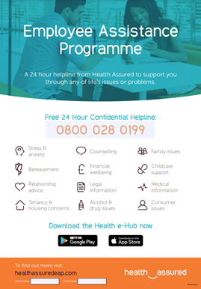The College subscribes each member of staff to an Employee Assistance Programme which allows colleagues access to counselling, advice on debt, lifestyle addictions, relationship, legal and pensions advice. This service is free and available 24hrs a day via a free confidential helpline.

Each year the College has a dedicated Staff Enrichment Day where the College closes to allow all members of the community to participate in a range of enrichments that are prepared for and offered by members of staff. This can involve walking, sports, cinema visits, museums, experiences (such as Breakout Rooms) etc.

Annually the College offers all staff a Christmas shopping day in the autumn term (the busiest and longest term in the academic year).

In addition, annually staff enrichment is offered throughout the academic year for colleagues to participate in (please see appendix 4 for recent examples).

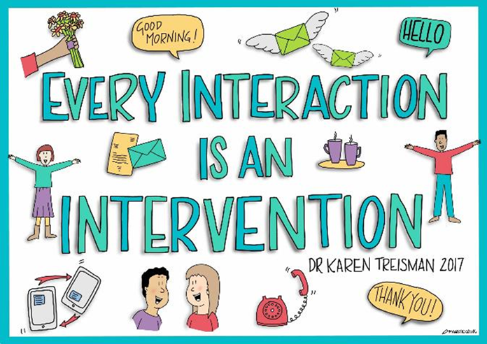

All staff are invited to participate in morning mindfulness sessions run (daily) through our Inclusive Learning team each day.

In addition, the College strategic plan clearly states that SLT will continuously review workloads and eliminate bureaucracy, where it exists.

To assist with managing expectations in relation to emails, workload and external communications, all college email sign-offs indicate:



Members of the Safeguarding Team and the Senior Tutor team are offered supervision on an ad hock, anonymous basis, facilitated by an external agency, Supervision in Schools. The College’s counsellors have paid for, monthly external supervision.

# **Support for Early Careers Teachers**

Early Career teachers are supported through a reduction in timetable to help with the demands of teaching and the ECF. They are allocated a mentor with whom they meet on a weekly basis for the two years of the programme. This support is provided for ECT’s who are eligible for both the statutory ECF but also provided to ECT’s who are not eligible due to not having QTS, we do not differentiate, believing every new teacher has the right to be supported as they begin their career. As well as being able to access whole college support through the EAA and other schemes, ECT’s are provided with bespoke workshops around work life balance, wellbeing and managing workload throughout the year. There is the opportunity to meet with other ECT’s as a support network alongside the induction lead here at the College.

# **Building Resilience**

Resilience building is a key component of maintaining positive mental health and wellbeing, however there does need to be a level of understanding of how we build resilience in order for it to be a successful contributor to us feeling good and functioning well.

The following diagrams and DfE explanation, helps to clarify what resilience means and how it can be “built”:

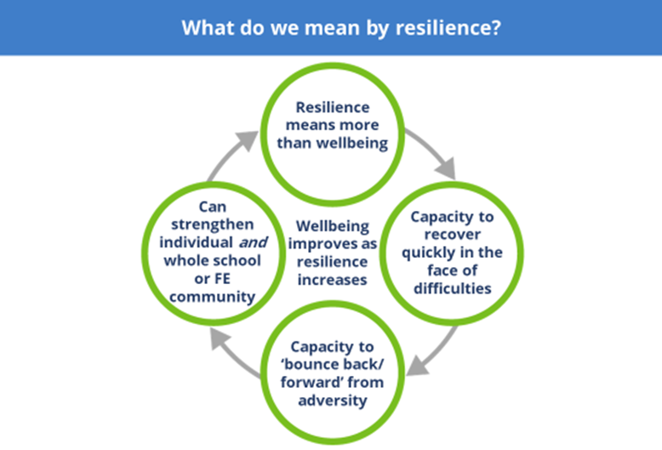(DfE 2020)

“Resilience might be less of a familiar concept than wellbeing. It’s important to be clear what we’re talking about with resilience, so that everyone has a shared language and understanding.

Resilience and wellbeing are linked, but resilience means more than wellbeing. Resilience includes the capacity to recover from setbacks quickly and cope well with life’s challenges – so to move forward, as well as ‘bounce back’ (or even bounce forward) after experiencing difficulties.

More resilience is generally linked to improved wellbeing; and wellbeing helps learning and growth that leads to greater resilience. If your whole school or further education community is resilient, that can also support personal resilience, and vice versa.” (DfE 2020)

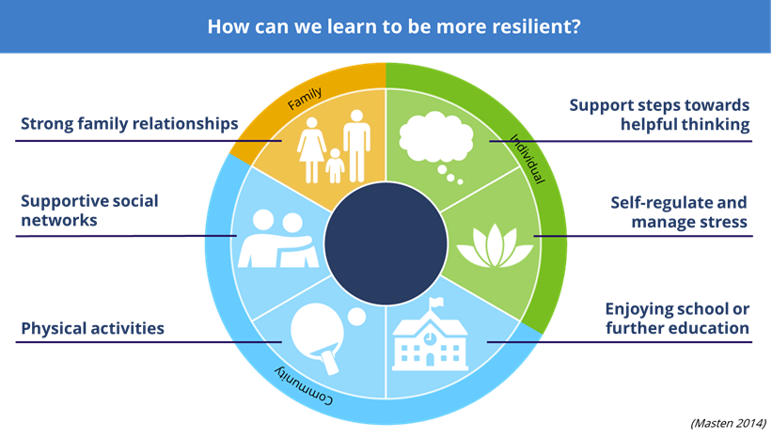

“This diagram highlights a range of things that help us to become more resilient. As you can see, relationships are key when we think about resilience.

We may already know some of these things, but it’s helpful to remind ourselves of the opportunities we have to interact and build our own and other people’s resilience, or perhaps just point people to sources of support or activities that might help them. It’s important that we draw on most or all of these things to support and build resilience.” (DfE 2020)

# **Promoting Positive Male Mental Health**

As the Office for National Statistics (ONS) report, suicide is the most common cause of death for men aged 20-49 years in England and Wales. Moreover, the ONS reported that males continue to account for three-quarters of suicide deaths registered in 2021 (4,129 male deaths compared with 1,454 female deaths) The College takes an active role in promoting positive male mental health to assist in eradicating the stigma around male stereotyping and the resistance to talk about mental ill health. Male role models are displayed around the College with signposting to internal college services as well as promoting external services dedicated to supporting males. The College’s tutorial CIP and “Spot Light On” activities also focus on male role models and examples to encourage open conversations about mental health amongst our male student population.

# **Training**

The DfE, in conjunction with MindEd and the Anna Freud Centre have created a post-pandemic training course for all personnel in educational settings in relation to mental wellbeing and how, as practitioners, we can support students and their learning.

Interested colleagues can access the training via the logo below (ctrl and click):

[](https://www.minded.org.uk/Component/Details/685525)

The College also supports wellbeing awareness via its “Be Curious” CPD pathway. Colleagues can voluntarily participate in this research led programme which encourages them to target a specific area of wellbeing that they have an interest in (for example healthy eating/nutrition and hydration). This research can be student or staff focussed.

Mental Health Awareness and First Aid courses are arranged through the College’s CPD programme.

The MindEd learning portal ([www.minded.org.uk](http://www.minded.org.uk)) provides free online training suitable for all staff wishing to know more about a specific mental health issue.

Details of qualified First Aiders are held by the reception staff.

# **Signposting/Support**

Appendix 1 and 2 in this strategy offer signposting to various organisations external to college and the College’s website also lists these.

Within the College, students have access to 1.4 FTE College Counsellors and colleagues have access to the aforementioned Employer Assist programme. In addition, members of the Safeguarding Team and the Senior Tutor team are offered supervision on an ad hock, anonymous basis, facilitated by TOG Mind.

## **Appendix I**

**Further information about Mental Health Conditions**

The term ‘mental health difficulty’ encompasses a range of conditions and details of these, the signs to look for and tips on how to support people with these problems are available on the Young Minds website. Young Minds is the UK’s leading charity committed to improving the emotional wellbeing and mental health of children and young people. You can also view short films created for either young people, parents/carers or professionals and download booklets: <http://www.youngminds.org.uk/>

For free online training, visit the MindEd website: <https://www.minded.org.uk/>

**Self-Harm**

This describes any behaviour where a young person causes harm to themselves in order to cope with thoughts, feelings or experiences they are not able to manage in any other way. It most frequently takes the form of cutting, burning or non-lethal overdoses in adolescents. It’s believed that between 10% and 20% of young people self-harm (Mental Health Foundation). [www.selfharm.co.uk](http://www.selfharm.co.uk)

[www.nshn.co.uk](http://www.nshn.co.uk)

**Depression**

Ups and downs are a normal part of life for us all, but for someone suffering from depression these ups and downs may be more extreme. Feelings of failure, hopelessness, numbness or sadness may invade their day to day life over an extended period of weeks or months, and have a significant impact on their behaviour and ability and motivation to engage in day to day activities.

[www.depressionalliance.org/information/what-depression](http://www.depressionalliance.org/information/what-depression)

**Anxiety, Panic Attacks and Phobias**

Anxiety can take many forms in children and young people and is something that each of us experiences at low levels as part of normal life. When thoughts of anxiety, fear or panic are repeatedly present over several weeks or months and/or they are beginning to impact on a person’s ability to access and enjoy day to day life, intervention is needed.

[www.anxietyuk.org.uk](http://www.anxietyuk.org.uk)

**Obsessions and Compulsions**

Obsessions describe intrusive thoughts or feelings that enter our minds which are disturbing or upsetting; compulsions are the behaviours we carry out in order to manage those thoughts or feelings. For example a young person may be constantly worried that their house will burn down if they don’t turn off all the switches before leaving the house, so may respond to these thoughts by repeatedly checking switches, perhaps returning home several times to do so. Obsessive Compulsive Disorder (OCD) takes many forms – it is not just about cleaning and checking.

[www.ocduk.org/ocd](http://www.ocduk.org/ocd)

**Suicidal Feelings**

Young people may experience complicated thoughts and feelings about wanting to end their lives. Some young people never act on these feelings though they may openly discuss and explore them. Others die suddenly from suicide, apparently out of the blue. NEVER assume a young person is attention-seeking if they talk about feeling suicidal.

[www.papyrus-uk.org](http://www.papyrus-uk.org)

**Eating Problems**

Food, weight and shape may be used as a way of coping with, or communicating about, difficult feelings and thoughts. Some young people develop eating disorders, such as anexoria nervosa (where food intake is restricted), binge eating disorder and bulimia nervosa (a cycle of bingeing and purging). In serious cases, these disorders can result in serious harm to vital organs within the body, and may be life-threatening.

[www.b-eat.co.uk/about-eating-disorders](http://www.b-eat.co.uk/about-eating-disorders)

**FOR MORE INFORMATION ABOUT THESE AND OTHER MENTAL HEALTH ILLNESSES, HOW TO SPOT THE SIGNS AND HOW TO HELP, CHECK OUT THE FOLLOWING WEBSITES:**

[www.youngminds.org](http://www.youngminds.org)

[www.mentalhealth.org.uk](http://www.mentalhealth.org.uk)

[www.mind.org.uk](http://www.mind.org.uk)

**Other recommended websites: Phone numbers:**

[www.lifesigns.org.uk](http://www.lifesigns.org.uk) ChildLine: 0800 1111

[www.childline.org.uk](http://www.childline.org.uk) Samaritans: 08457 90 90 90

[www.samaritans.org.uk](http://www.samaritans.org.uk) Family Lives: 0808 800 2222

[www.harmless.org.uk](http://www.harmless.org.uk) Young Minds: 0808 802 5544

## **Appendix 2**

**Sources of support in the local community:**

* kooth.com - Free Online counselling service 12-10pm weekdays and 6pm-10pm weekends.
* Off the Record Young Peoples Counselling, Clarendon Square, Hyde - Drop In Wednesday 3-6pm (just drop in for a chat) or phone 0161 355 3553 (self-referral).
* The Hive Katherine, St. Ashton under Lyne 0161 330 9223 - Drop in 4-8pm every Wed.
* Anthony Seddon Fund, 12 George Street, Ashton under Lyne - 0161 376 4439 or Thursday 4-7pm drop-in, including refreshments.
* 42nd Street, Manchester - 0161 228 1888 (can self-refer)
* CALM - Campaign against living miserably for males experiencing Mental Health Issues - Freephone 0800 585858, www.thecalmzone.net
* Themix.org.uk - Chat/text support and helpline number on website
* Brook (confidential sexual health advice/treatment) - Oldham Branch, 0161 627 0200.

**If you are in crisis and feeling suicidal:**

* If you are experiencing any distressful/uncomfortable thoughts and feelings try and confide in a friend or relative or seek help from any of the below crisis services. Most are Freephone.
* In an emergency, the hospital is your first port for help.
* Present yourself at the A&E Department anytime or contact Tameside Hospital on 0161 922 6000 for telephone advice and support.

**Telephone advice and support for people who are having a mental health crisis and/or feel suicidal is available:**

* Samaritans - Freephone 116 123, email jo@samaritans.org, 24hours everyday.
* Papyrus - Papyrus-uk.org
* HOPEline UK - 0800 068 41 41 for support

## **Appendix 3**

**Talking to students when they make mental health disclosures**

The following guidance is provided by The Charlie Waller Memorial Trust [www.cwmt.org.uk](http://www.cwmt.org.uk):

The advice below is from students themselves, in their own words, together with some additional ideas to help you with initial conversations with students. This advice should be considered alongside relevant policies.

**Focus on Listening…..**

*“She listened, and I mean REALLY listened. She didn’t interrupt me or ask me to explain myself or anything, she just let me talk and talk and talk. I had been unsure about talking to anyone but I knew quite quickly that I’d chosen the right person to talk to and that it would be a turning point.”*

If a student has come to you, it’s because they trust you and feel a need to share their problems with someone. Let them talk. Ask occasional open questions if you need to, in order to encourage them to keep exploring their feelings and opening up to you. Just letting them pour out their feelings and thoughts will make a huge difference and marks a huge first step forwards. Up until now they may not have spoken to anyone else about this and may not even have admitted to themselves there is a problem.

**Don’t talk too much …..**

*“Sometimes it’s hard to explain what’s going on in my head – it doesn’t make a lot of sense and I’ve kind of gotten used to keeping myself to myself. But just ‘cos I’m struggling to find the right words doesn’t mean you should help me. Just keep quiet, I’ll get there in the end.”*

The student should be talking at least three quarters of the time. If that’s not the case, then you need to redress the balance. You are there to listen, not talk. Sometimes the conversation may lapse into silence. Try not to feel too quickly that you need to fill the gap but wait. This may lead to them being able to explore their feelings more deeply. Of course you do need to interject occasionally to show you are listening and concentrating on what they’re saying, and to show you understand. Don’t feel the urge to over-analyse the situation or try to look for answers. This can come later – your role is a supportive listener.

**Don’t pretend to understand…..**

*“I think that all teachers got taught on some course somewhere to say ‘I understand how that must feel’ the moment you open up. YOU DON’T – don’t even pretend to, it’s not helpful, it’s insulting.”*

The concept of a mental health difficulty such as an eating disorder or obsessive compulsive disorder (OCD) can seem completely alien if you’ve never experienced these difficulties first hand. You may find yourself wondering why on earth someone would do these things to themselves, but don’t explore those feelings with the sufferer. Instead, listen hard to what they say and encourage them to talk and you’ll slowly understand what steps they might be ready to take in order to start making some changes.

**Don’t avoid making eye contact …..**

*“She was so disgusted by what I told her that she couldn’t bear to look at me.”*

It’s important to try to maintain a natural level of eye contact (even if you have to think very hard about doing so and it doesn’t feel natural to you at all). If you make too much eye contact, the student may interpret this as you sharing at them. They may think you are horrified about what they’re saying or think they are ‘a freak’. On the other hand, if you don’t make eye contact at all then a student may interpret this as you being disgusted by them to the extent that you can’t bear to look at them – or that you aren’t even listening. Making an effort to maintain natural eye contact will convey a positive message.

**Offer support …..**

*“I was worried how she’d react, but my Mum just listened then said ‘How can I support you?’ – no one had asked me that before and it made me realise that she cared. Between us we thought of some really practical things she could do to help me stop self-harming.”*

Never leave this kind of conversation without agreeing next steps. These will be informed by your conversations with appropriate colleagues and the schools’ policies on such issues. Whatever happens, you should have some form of next steps to carry out after the conversation because this will help the student to realise that you’re working with them to move things forward.

**Acknowledge how hard it is to discuss these things …..**

*“Talking about my bingeing for the first time was the hardest thing I ever did. When I was done talking, my teacher looked me in the eye and said ‘That must have been really tough’ – he was right, it was, but it meant so much that he realised what a big deal it was for me.”*

It can take a young person weeks or even months to admit they need help. If a student chooses to confide in you, you should feel proud and privileged that they have such a high level of trust in you. Acknowledging both how brave they have been and how glad you are they chose to speak to you, conveys positive messages of support.

**Don’t assume that an apparently negative response is actually a negative response ….**

*“The anorexic voice in my head was telling me to push help away so I was saying no. But there was a tiny part of me that wanted to get better. I just couldn’t say it out loud else I’d have to punish myself.”*

Despite the fact that a student has confided in you, and may even have expressed a desire to get on top of their illness, that doesn’t mean they’ll readily accept help. The illness may ensure they resist any form of help for as long as possible. Don’t be offended or upset if your offers of help are met with anger, indifference or insolence. It’s the illness talking, not the student.

**Never break your promises …..**

*“Whatever you say you’ll do you have to do or else the trust we’ve built in you will be smashed to smithereens. And never lie. Just be honest. If you’re going to tell someone, just be upfront about it. We can handle that, what we can’t handle is having our trust broken.”*

Above all else, a student needs to know they can trust you. That means if they want you to keep their issues confidential and you can’t then you must be honest. Explain that, whilst you can’t keep it secret, you can ensure it’s handled within the College’s strategy of confidentiality and that only those who need to know about it in order to help will be told. You can also be honest about the fact that you don’t have all the answers or aren’t exactly sure that will happen next. Consider yourself the student’s ally rather than their saviour and think about which next steps you can take together, always ensuring you follow relevant policies and consult appropriate colleagues.

## **Appendix 4**

