**Welcome to the Biology department!**

Our aim is to ensure that you thoroughly enjoy studying Biology and we will provide help, support and guidance throughout the course (and a kick up the bum when you need it!).

We want to ensure that you reach your full potential and we hope that the enthusiasm of our highly qualified staff will allow you to reach your goal.

You will find excellent laboratories that are both well-equipped and pleasant to work in. In addition, there is information about careers and university courses in ST2.1 (the Science & Technology computer room).

Whilst we expect you to work hard, we hope that you find your Biology lessons stimulating and enjoyable.

**Your background in Biology**

Before arriving here many of you will have studied Science at school. Some of you will have followed separate subject Science courses and others Double Science courses. For this reason we do not assume that everyone has a full knowledge of GCSE Biology topics. Rather, we approach each AS level topic by starting with the basics and then building upon this.

When we cover a topic which you have met at GCSE, do not assume that you know it all already - we will be teaching it in more depth and expecting more detail and understanding than before. Don’t worry if you struggle at first - this is quite normal. As long as you are prepared to work hard and come and ask for help, you will get over this initial period.

**AS level Biology**

Our department comprises:

Sara Petts- Sara.Petts@asfc.ac.uk

Gemma Coles- Gemma.Coles@asfc.ac.uk

Alison Isaac (technician)

Troy Weston (technician)

During the course you may be taught by more than one of us. Remember that if you have a problem and require help you may ask **any** one of the Biology tutors. When not teaching we can be found in the Science office.

**Course at a glance**

At Ashton we follow the AQA Biology Specification, which is divided into the following broad topic areas:

Year 1 Topics:

1. Biological molecules
2. Cells
3. Organisms exchange substances with their surroundings
4. Genetic information, variation and relationships between organisms

Year 2 Topics:

1. Energy transfers in and between organisms
2. Organisms respond to changes in their internal and external environments
3. Genetics, populations, evolution and ecosystems
4. The control of gene expression

Assessment is linear, with all the exams at the end of year 2. There will be 3 papers:



**Assessment of Maths & Practical Skills**

At least 10% of the marks in the exams will require the use of mathematical skills

At least 15% of the marks in the exam papers will assess your knowledge, skills and understanding in relation to practical skills. A separate endorsement of practical skills will be awarded alongside the A-level (on a pass/fail basis). This will be assessed by teachers and will be based on direct observation of your competency in a range of skills (see Practical Handbook for more details).

You can obtain further information via

<http://filestore.aqa.org.uk/resources/biology/specifications/AQA-7401-7402-SP-2015-V1-1.PDF>

**How to get help**

No one expects you to know the answers to all the questions you might be asked just by coming to lessons. You must be prepared to seek out assistance if you are to make progress at this level.

You can obtain help in a number of ways:

1. **Speak to your teacher** at the end of the lesson. If the query is straightforward, you can be given some help. If it will take more time to explain than is available before the next lesson, your teacher will arrange a mutually convenient time for your problem to be discussed.
2. **Come and find any of the Biology staff** when you are free. As long as there is someone available to speak to you, your problem can be discussed immediately.
3. Come to one of the **Subject Support Sessions** that we run at various times throughout the year. These are informal sessions where problems arising from class work or homework assignments can be discussed with one of the Biology staff. Check the notices around the Biology labs for details of times and places of topic specific sessions.

**Biology department**

**What you can expect from us:**

* The setting of worthwhile tasks to improve Biology skills and knowledge through a variety of approaches
* Guidance and monitoring to improve your Biology skills
* The regular setting, marking and prompt return of work
* Regular feedback to identify problems, find solutions and give direction for the future
* To try to make lessons enjoyable, interesting and stimulating
* Full coverage of the syllabus and preparation for examination
* Confirmation in the first few weeks that the course is the right one for you and your skills. If this is not the case we will recommend transfer to something more suitable for you
* Daily support from either a teacher or A2 students

**What we expect from you:**

* To come prepared to work hard in lessons and participate fully. This includes having completed your lesson preparation work as well as making sure you have a pen, pencil, ruler and calculator
* Safe working practice throughout
* Completion of all work set to realistic deadlines
* Work is completed at the best possible standard you can attain
* If you are absent through illness / visit to a university etc., you take responsibility to complete any work missed
* You get help from a teacher or classmate if you have not understood work done in class, need homework help, or need to catch up after absence
* Do more than just the set work! Just turning up to class and doing homework is the absolute bare minimum. For a high grade you need to have excellent attendance, great punctuality, high grades in homework and tests and have done extra reading, practising, reviewing and researching
* No inappropriate or unauthorised use of mobile phones in lessons
* Self motivation! This is your AS level!
* Complete a **minimum** of 4 hours private study per week. More if you’re aiming for a high grade!

**Don’t forget:**

* If you are unable to attend a class you **must** call the college reception to inform us. Tel. **0161 330 2330**
* If you need to speak to a member of the Biology team, call ext. **302**
* Alternatively you can contact us by email.

Initial Assessment

In around two weeks you will sit an End of Induction Test. This test is very important and its purpose is to allow you to decide if Biology is the correct course for you.

*Why do we want to ensure Biology is the best course for you?*

* We want you to pass! Pass grades are A-E at A level.
* We want to give you the best chance to achieve high grades next year and to be accepted onto your chosen course at university. The second year of any A level subject, known as A2, is more difficult than the first year (AS). Therefore, to continue studying after your first year it is sensible to have achieved a minimum of a D grade in that subject. Second year A level students study a minimum of **three** subjects at A2.

AS Biology Results Ashton Sixth Form College 2014-2015

There were 97 AS Biology students in 2014-2015, here are their AS grades:

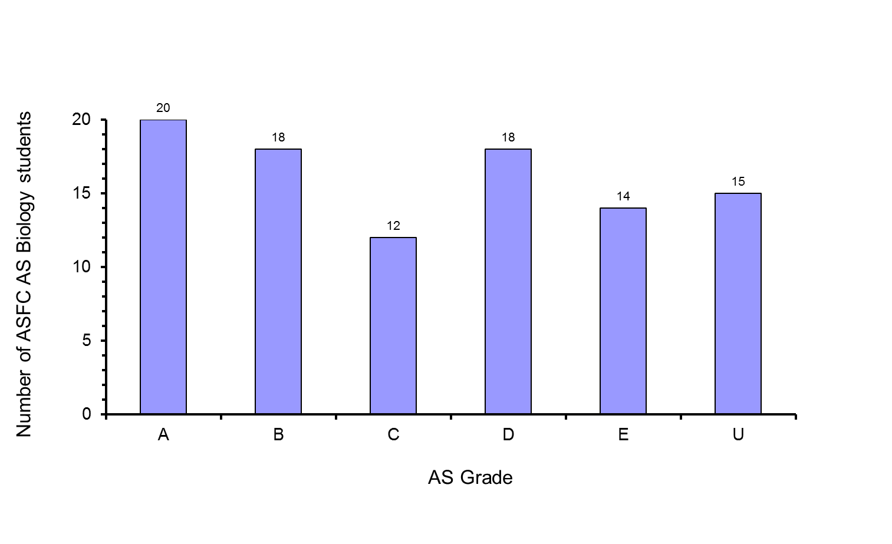

These are excellent results. Many of these students will now be able to apply to prestigious universities and are in an excellent position to be able to fulfil their dreams of studying a particularly demanding course at university such as Medicine or Dentistry.

*As an Ashton Sixth Form College Biology student you should achieve your target grade. Here’s why:*

* Your Average GCSE Point Score predicts the grade you are most likely to achieve at the end of your AS year. This is known as your target grade. Your target grade is currently being worked out but as you have been enrolled onto the course your predicted grade is unlikely to be less than a D.
* We will provide you with a set of notes that include enough information in them for you to obtain an A grade. We will also provide you with question booklets that include past examination questions so that you are always practising your exam technique.
* Your teachers are highly qualified in Biology and have many years teaching experience.
* We will constantly monitor your progress through regular testing and retesting. Tests are mostly past examination questions.

*With so much support provided by the college how can students fail AS Biology or not achieve their target grade?*

GOOD QUESTION! Science and Maths A levels are extremely demanding courses. They require students to work very hard and to have a dedicated approach to their studies.

*What do you need to do to achieve your target grade?*

In class you are not expected to handwrite page after page of notes on the concepts studied in each lesson. Instead, we provide you with a set of notes for each topic with enough information in them to achieve an A grade. So, all you have to do is:

1. LEARN the information i.e. MEMORISE it

2. APPLY the information learnt by PRACTISING exam questions.

This of course takes a lot of time. We recommend you spend a minimum of 5 hours a week MEMORISING the information delivered in the lessons and completing homework. You should also spend time PRACTISING as many past examination questions as you can and ensure you check your answers against the mark schemes to help you improve. The more past examination questions you do, the better your grade will be.

*Why is the End of Induction Test so important?*

**Student 1**

AS Results:

Biology A

Maths B

Psychology A

Religious Studies A

Average GCSE Point Score: 6.1 Target Grade: B

Biology End of Induction Test Result: 69% Grade B

Below are individual student cases.

**Student 4**

AS Results:

Biology D

Business Studies D

History E

Psychology B

Average GCSE Point Score: 5.5 Target Grade: C

Biology End of Induction Test Result: 64% Grade C

**Student 3**

AS Results:

Biology U

Chemistry U

Maths U

Psychology C

Average GCSE Point Score: 5.5 Target Grade: C

Biology End of Induction Test Result: 49% Grade U

**Student 2**

AS Results:

Biology E

Chemistry E

Maths E

History C

Average GCSE Point Score: 5.7 Target Grade: C

Biology End of Induction Test Result: 56% Grade E

Take the induction assessments seriously. It will give you a good indication of how you will perform at the end of your AS year and help you decide if Biology is the best course for you now.