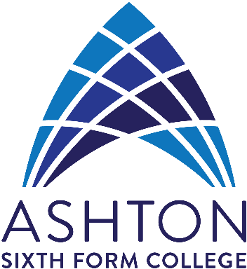Continuing your GCSE English
Welcome to the ASFC English Department!
We have a proven record of GCSE success and the college is, without doubt, the best place in the area for you to be continuing your studies of English Language.
So what’s ahead?

SEP- OCT: EARLY EXAM PHASE
- Assessment/discussion to decide on November Exam entries (note: exam dates this year are subject to change due to the fluctuating circumstances of the coronavirus pandemic).
- November ‘20 Exam (if taking place) will be an early opportunity to sit the English Language exams (we use Edexcel exam board).
- Approximately 6 weeks of revision and preparation prior to the exams will be focused on the exam paper format and areas for individual improvement.

NOV- DEC: TRANSITION PHASE
- Exams: week commencing 2/11 (subject to change)
- Awaiting results of November exam
- Review of attendance requirements
- Learning time utilised for students requiring additional support

JAN- JUNE: RESULTS/ NEW ENTRY PHASE
- Exam results early January (subject to change)… End of course for those passed!
- New June exam entry for remaining students

Tips:
- Don’t throw away your school books! Use them to revise the skills required
- Revise your English Language work (not English Literature!).
- Keep your Reading and Writing skills fresh via the resources on the BBC GCSE Bitesize website (Edexcel resources).
- Access the Edexcel exam board website for past papers etc.
- Keep reading! For example, read online articles about interesting people and places or perhaps short stories.

Finally, contact us if you have any further queries on 0161 330 2330 x 256 or email Karen on kjp@asfc.ac.uk

See you soon!

