,A Level English (A Level English Language, A Level English Literature and A Level English Language & Literature Combined)
For all English subjects – the initial assignment needs to be completed for your first lesson.

A LEVEL ENGLISH LANGUAGE

Initial assignment: How does the language I use make me who I am?

Consider your own idiolect and how you personally use language and the features of your speech.

The following bullet points will help you:-

Consider:-

- How you use language differently in different contexts

- How you are influenced by the language of others

- The unique characteristics of your language

- Aspects of your accent and dialect and what they reveal about you

- Your use of ‘teen language’ and slang

- Any other ideas you feel are relevant to the task

Aim for about 500 words.

A LEVEL ENGLISH LANGUAGE AND LITERATURE
Reading Students wishing to study this course must have read “Dracula” by Bram Stoker before the course starts!!!

Initial assignment
Original Writing – You may wish to write a monologue or a novel extract or opening. This need to be 500 words in any genre of your choice.
Then write a paragraph of analytical writing describing your language and literary choices.

A LEVEL ENGLISH LITERATURE
Reading Students wishing to study this course must have read “Frankenstein” by Mary Shelley before the course starts!!! You will be set an assignment on this text in the first half term.

Initial assignment
Consider how the books you have read have influenced you.
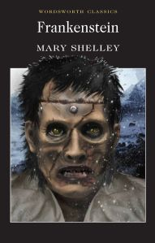
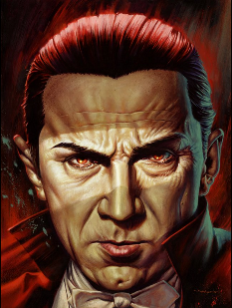
Write a 500 word account of any plays, novels or poems which have influenced you. Consider your emotional responses, any ideas or concepts they made you consider, and how these texts helped you develop and grow as an individual.

