A/S Induction task.
Research an artist/photographer who inspires you.
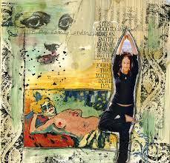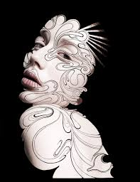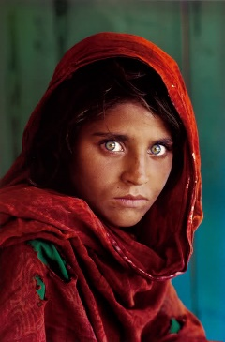

They could be old or modern, using any media you like, linking to photoghraphy.
The only criteria is that they are someone you can find out information about and fairly well known.
Hand write a 200 word assignment explaining WHY you choose them.
WHAT it is about their work which you like and a small biography about them.
* Choose 3 pieces of their work to show this information and explain what you think the artist is showing/what is the story you see? *
Discuss lighting, colour, composition, depth of field, subject matter, your likes and dislikes etc.
Some examples of artists you might choose to research,
Gillian Wearing, Richard Billingham, Bill Brandt, Ansel Adams, Annie Leibovitz, Lichtfaktor, Steve Mc Curry, David Bailey, Man Ray, Robert Mappelthorne, Muybridge.
Or find your own well known person to research.

