**Year 1 Psychology**

**Research Task**

**Task Instructions:**

**The Title:** ‘The Psychology of an Effective Learner’

**Task:** On the following pages there are three articles on **three different factors** that help make an effective learner (Memory, Growth Mindset and Grit). Your task is to **handwrite a 1-2 side summary** on lined A4 paper on what helps people to learn effectively which **includes information taken from each of the 3 articles**. You must **write up your report in your own words** though. In other words, do not just copy from the documents or you will be asked to do it again. Remember, this must be **written by hand** so no typing!

**Deadline:** This must be **brought in to your first Psychology lesson**.

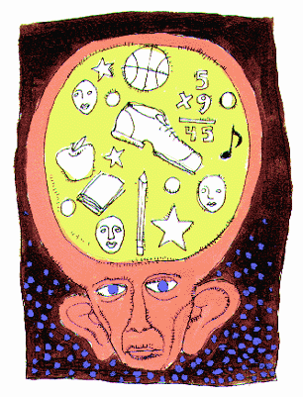**Article 1: Memory:**

One aspect of learning is being able to remember key facts, figures, terms and ideas. Our memory processes determine how information is [perceived](http://en.wikipedia.org/wiki/Perceive), [processed](http://en.wikipedia.org/wiki/Information_processing), stored, [retrieved](http://en.wikipedia.org/wiki/Information_retrieval) and [forgotten](http://en.wikipedia.org/wiki/Forgot). Cognitive psychologists (who study different mental processes such as memory) argue that memory is split up into a **short-term memory (STM)** store which only holds memory for a short period and a **long-term memory (LTM)** store which holds memory possibly as long as a lifetime. Cognitive psychologists like Atkinson and Shiffrin argue that **rehearsal** (repeated practice) helps a memory pass from STM (which is only a temporary store) to LTM which is a more permanent memory store.

Krug, Davis and Glover conducted an experiment to see which rehearsal strategies help successfully transfer information from STM into LTM. They found that reading a passage of text repeatedly in one go (**massed rehearsal**) was much less successful than the same amount of rehearsal but with a one week delay between readings (**distributed rehearsal**). This suggests trying to rehearse material all in one go and on one occasion is not as effective as more spaced out but regular rehearsal.

Cognitive psychologists have also demonstrated the benefits of using [**mnemonics**](http://en.wikipedia.org/wiki/Mnemonics) (memory aids). Different mnemonics that have been tested include acronyms and acrostics, rhymes and mind maps (which aid memory because they require an understanding of how information is structured).

Bower et al (1969) conducted an experiment into memory improvement using **mind maps**. Half of their participants were given a list of minerals to remember written in no particular order and the other half of the participants were given the same minerals to remember but this time they were put into a structured mind map with all the metals clearly grouped together and all the stones clearly grouped together too. They found that participants given the more structured display of words to remember could remember more than those given the same words in no particular order. This shows **organisation** of materials aids memory as it helps to group information together into more meaningful ‘chunks’.



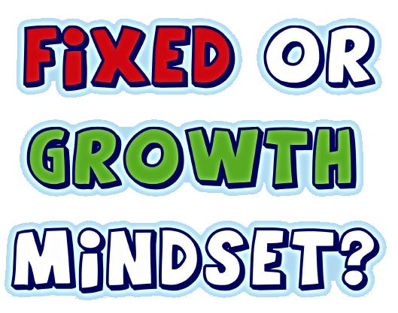**Article 2: Growth Mindset:**

Psychologsist, Carol Dweck argues that there are two types of mindsets that people use in life. These are known as the fixed mindset or the growth mindset.

People with a **fixed mindset** believe their talents and abilities cannot be improved through any means. They feel that they are born with a certain amount of talent and typically do not wish to challenge their abilities due to the possibility of failure. Individuals with a fixed mindset frequently guard themselves against situations in which they feel they need to prove their personal worth. Challenges are frequently viewed negatively due to a fear of failure.

However, people with a **growth mindset** believe their abilities (e.g. their ability to write, remember information, and perform well in sports or in mathematical tasks) can be improved through effort, hard work and persistence. When presented with an obstacle, those practising a growth mindset tend to rise to the challenge. People of the growth mindset do not fear failure; instead, they view it as a chance to improve themselves.

One study by Dweck at al (2007) hundreds of students were followed as they made the transition to 7th grade in America. They found that students with a growth mindset were more motivated to learn and show higher levels of effort. These students then went on to outperform those with a fixed mindset in Maths. Furthermore, this gap then continued to increase over the following two-year period. Those with the two mindsets had entered 7th grade with similar past achievement, but because of their mindsets their Maths grades pulled apart during this challenging time. Similar results have been shown in a variety of subject areas.

Dweck explains that mindsets can drive many aspects of our lives, ranging from success in education and in careers, to sports and even success in parenting and relationships. She reveals how prominent members of a variety of fields – business, literature, music, science, and sports - possess the growth mindset to achieve personal goals and dreams. Furthermore, Dweck has found that mindset is not fixed and that it is possible for anyone to learn to change their mindset at any age or at any stage in life.

In education, a growth mindset is one where the learner focuses on expanding their knowledge and ways of thinking and investigating the world. As a result, grades should not be seen as an end in themselves, but as a means to grow. Someone with a growth mindset therefore tends to embrace challenges, be intrigued by the mistakes they make (using them as a way of identifying areas for improvement and working out how to improve them), learn from criticism and see effort as the way to achieve.

**Grit (the personality trait)**

‘Grit’ has been used as a term in psychology to refer to the personality trait some individuals possess that has been strongly linked to educational and career success. A ‘gritty’ individual is a person **passion for a particular long-term goal (e.g. achieving in their chosen educational subjects) as well as a powerful motivation and level of effort to achieve their goal**. This perseverance of effort enables individuals with a ‘gritty’ personality to overcome obstacles, challenges or failures that lie within their path to success and serves as a driving force in allowing them to achieve their goals.

For years, many experts believed that the best predictor of future success was level of intelligence (e.g. people often expect so-called ‘gifted and talented individuals to be the most successful). However, research has shown that intelligence, on its own, is not a very strong predictor of future success in education or in career success. In fact, there is a huge amount of variation amongst intelligent people that are highly successful and equally intelligent people who are less successful. This prompted one of the early questions asked in grit research, “Why do some individuals accomplish more than others of equal intelligence?” Furthermore, studies consistently show that many individuals with relatively average or even low IQ scores achieve much more than some individuals with comparatively high IQ scores.

In response to these issues, Duckworth et al. (2007) began conducting psychological tests to see whether ‘grit’ is actually a better predictor of future success. They defined grit as an ability to maintain determination and motivation over long periods despite experiences with failure and adversity. Their passion and commitment towards the long-term objective is the overriding factor that provides the stamina required to “stay the course” amid challenges and set-backs. Essentially, the Grittier person is focused on winning the [marathon](http://en.wikipedia.org/wiki/Marathon), not the [sprint](http://en.wikipedia.org/wiki/Sprint_(race)). Whilst some individuals are more easily bored and quick to give up or become disappointed with a lack of success, the gritty individual stays the course and uses failure to their advantage.

Duckworth et al. (2007) studied people in different settings including students at Ivy League universities (high achieving universities in America), cadets at the [United States Military Academy](http://en.wikipedia.org/wiki/United_States_Military_Academy), and participants in a National Spelling competition. They found that ‘grittiness’ was found to be the best predictor of success in all of these settings, over and above other personality traits. Higher levels of grit were highly associated with a better grade point average (GPA) in Ivy League education, better retention in the [United States Military Academy](http://en.wikipedia.org/wiki/United_States_Military_Academy) (i.e. not giving up or dropping out) and harder work and better performance in the National Spelling competition. These different results provide [empirical evidence](http://en.wikipedia.org/wiki/Empirical_evidence) that grit can account for significant [variance](http://en.wikipedia.org/wiki/Variance) in performance across a variety of settings. Grit was more closely linked with success than [IQ](http://en.wikipedia.org/wiki/IQ) and can account for variance over and above other personality traits too.

