UNIT – C1 Developing Coaching Skills
Assignment: Introduction to Coaching
Academic Year: 2020/2021
Teacher: Andrew Leech
Date Out: 20 August 2020
Date In: First Lesson
STUDENT NAME
___________________________

BTEC Nationals Extended Diploma in Football Coaching
WELCOME TO ASFC
Welcome to Ashton Sixth Form College and CONGRATUALTIONS in working hard during your GCSE’s to enable you to continue to study and further your education. All of your teachers within the PE department are looking forward to working with you during the two short years you have here at Ashton Sixth Form College in preparation of your next steps onto employment or university. This may seem like a long way off but time will go extremely quickly and each day you spend at college must be used to develop your knowledge, skills and confidence within a variety of sporting topics in the classroom and within a practical based environment. If you have any questions please do not hesitate to ask!

Unit Introduction
An assistant coach plays an essential part in improving the performance of athletes, sports and activity leisure performers, and participants. Sports coaches have many different aspects to consider in the coaching environment and for the wider team. The development of knowledge and practical skills is vastly different across coaching disciplines and the assistant coach helps to ensure that it is possible to achieve the highest standard of coaching overall.
In this unit, you will develop an understanding of coaching requirements and put assistant coaching skills into practice. You will explore the skills, roles and responsibilities of an assistant coach and how industry legislation and guidelines relate to assistant coaching practice. You will then explore different methods to improve skills, techniques and tactics to improve performance. You will plan and prepare a coaching session, which you will deliver under the supervision of a qualified coach.
You will reflect and evaluate the effectiveness of your delivery, to produce a development plan for future practice. You will then use this development plan to prepare, plan and deliver a series of coaching sessions under the supervision of a qualified coach.
This unit will help you to progress to employment in the coaching and education sectors. The unit will also help you to progress to further study in higher education and to professional qualifications in sports coaching, physical education and sports management.

Learning Outcomes
In this unit you will:
LA.A – Explore the responsibilities of an assistant coach.
LA.B – Prepare sport and activity sessions.

Task | Task Description | Grading Criteria | Submission Date | Assessor
1 | Explain the Roles and Responsibilities of an assistant coach of your choice. E.g Brian Kidd or Mike Phelen.  - Explain the role and their ‘Personal Contribution’ of your assistant coach within their team.  - In addition explain the responsibility of your assistant coach to have a high level of ‘Professional Conduct’ when working within their team. | Part  P1 | First Lesson | A.Leech
Evidence you must produce for this task.
Word Document
Criteria covered by this task:
Part P1 | Explain the roles and responsibilities of an assistant coach.

Task | Task Description | Grading Criteria | Submission Date | Assessor
2 | In preparation of starting to conduct some coaching sessions, design 3 coaching session diagrams within 3 different sports. Explain the session and coaching points where possible. | Part  P3 | First Lesson | A.Leech
Evidence you must produce for this task.
3 Coaching Session Diagrams
Criteria covered by this task:
Part P3 | Plan for activity sessions.

Task | Task Description | Grading Criteria | Submission Date | Assessor
3 | Describe the current Reporting of Injuries, Diseases and Dangerous Occurrences Regulations (RIDDOR) and explain why RIDDOR is important within a sports based environment. | Part  P2 | First Lesson | A.Leech
Evidence you must produce for this task.
Word Document
Criteria covered by this task:
Part P2 | Describe how current industry legislation, guidelines, organisational policies and procedures impact on good practice.

Coaching - Initial Assignment
This initial assignment has been designed to enable your teachers to get to know you as quickly as possible and to work towards achieving some assessment criteria. The quicker we can get to know you, the quicker we can start to work together to complete coursework to the highest standard possible. This may seem a little daunting at first, but your teachers will be introducing themselves at your first lesson in which they will feel slightly nervous too! Try and answer all the questions in as much detail as possible. To complete this initial assignment you must
- Research Roles and Responsibilities of an assistant sports coach.
- Complete 3 coaching session plans.
- Research “RIDDOR” and explain why it is important in a sports based environment.
Please start by introducing yourself.

Do you have any hobbies?

Other than your hobbies what other sports can you play?

Do you have any coaching qualifications?

Do you/have you ever refereed within any sports?

 | Monday | Tuesday | Wednesday | Thursday | Friday | Saturday | Sunday
Early Morning
Morning
Mid-day
Evening
Late Evening
Please complete the table below to highlight your sporting week

As part of your qualification you have to conduct some coaching as an assistant coach. Please state which club/school you will use to help achieve your qualification.
- Club/School:
- Age Group:
- Name of Contact:
- Contact telephone number:
- Can evidence be provided?

If you currently have no contacts to help achieve your assistant coaching hours, please state which schools/clubs you will try to contact to help you gain experience.

Please explain in detail your current coaching strengths and weaknesses.

Your second task is to explain the Roles and Responsibilities of an assistant coach of your choice.
- Explain their role in how your coach makes a ‘Personal Contribution’ within their team and the importance.
- In addition explain the responsibility of your assistant coach to have a high level of ‘Professional Conduct’ when working with their team.

Coach Name:_________________________ Team: __________________________

Your third task is to complete three coaching session diagrams within a sport of your choice. Use the example below as a guide, but consider how you could improve the example.
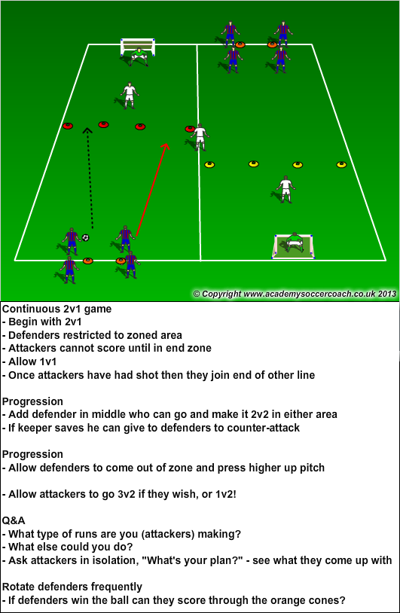

Your final task is to research ‘RIDDOR’. Please explain what RIDDOR is and how important RIDDOR is within a sports based environment.

